**Link for the spreadsheet :** [**IT Ticket Project_2025 - Google Drive**](https://drive.google.com/drive/folders/1xd3D0F7IrtSNY8fufMIp9o4OfZgbiSs2)

**Subjective Question:**

1. **If there is an investment, should it be used to hire more IT agents, improve training programs, or upgrade ticket management software?**

**Analysis: Perform a cost-benefit analysis using ticket resolution and satisfaction metrics.**

1. Based on the cost-benefit analysis, the recommendation is to upgrade the ticket management software to enhance efficiency and customer satisfaction.

**Reference:**

This analysis evaluates the following factors to determine whether to hire more IT agents, improve training programs, or upgrade ticket management software:

* **Hiring IT Agents**: Average satisfaction scores, resolution times, and ticket counts per agent.
* **Improving Training**: Satisfaction-to-resolution time ratios.
* **Upgrading Ticket Software**: Comparison of priority and severity alignment.

**Approach:**

1. **Hiring IT Agents**:
   * Analyzed average satisfaction scores and resolution times per agent.
   * Evaluated the number of tickets handled by each agent to assess workload.
   * Pivot Table: Calculated average satisfaction scores, resolution times, and ticket counts for each agent.
2. **Improving Training**:
   * Evaluated agents’ satisfaction-to-resolution time ratios to identify performance gaps.
   * Pivot Table: Analyzed the ratios to spot agents who may benefit from additional training.
3. **Upgrading Ticket Software**:
   * Compared priority and severity alignment.
   * Examined mismatches in assigning high-severity tickets to high-priority levels to assess the effectiveness of the current software.

**Insights:**

1. **Hiring IT Agents**:
   * Agents with higher ticket counts tend to have higher resolution times and lower satisfaction rates.
   * There is a noticeable variation in satisfaction scores across agents, suggesting some agents may be overburdened or less efficient.
2. **Improving Training**:
   * Agents with lower satisfaction-to-resolution time ratios may benefit from further training to improve their efficiency in resolving tickets without compromising satisfaction.
3. **Upgrading Ticket Software**:
   * There is a slight mismatch between severity and priority, where high-severity tickets are not always assigned the highest priority, indicating potential software inefficiencies.

**Recommendations:**

1. **Hiring IT Agents**:
   * Consider hiring more IT agents to balance workload and reduce resolution times, especially for agents handling high ticket volumes.
   * Focus on agents with lower satisfaction scores and higher resolution times for additional training.
2. **Improving Training**:
   * Identify agents with low satisfaction-to-resolution time ratios and invest in targeted training to enhance their efficiency and customer satisfaction.
   * A bar graph with numbers and lines

     Description automatically generated
3. **Upgrading Ticket Software**:
   * Investigate potential software upgrades to improve priority-severity matching and ensure that high-severity tickets are assigned appropriate priority levels for faster resolution.

|  |  |  |  |  |
| --- | --- | --- | --- | --- |
| *COUNTA of ID Ticket* | *Priority* |  |  |  |
| *Severity* | 0 - Unassiged | 1 - Low | 2 - Mid | 3 - High |
| 0 - Unclasified | 115 | 80 | 55 | 106 |
| 1 - Minor | 626 | 549 | 407 | 676 |
| 2 - Normal | 26826 | 15282 | 14468 | 32080 |
| 3 - Mayor | 1434 | 614 | 713 | 2075 |
| 4 - Urgent | 409 | 169 | 202 | 612 |

**2. Which agents need additional training based on their performance metrics?Analysis: Identify agents with the lowest satisfaction ratings and longest resolution times.**

A.The following agent id needs additional training

|  |
| --- |
| 4 |
| 40 |
| 18 |
| 46 |
| 43 |
| 45 |
| 33 |
| 41 |
| 3 |
| 9 |
| 25 |
| 39 |
| 16 |
| 37 |
| 28 |
| 30 |
| 1 |
| 11 |
| 19 |
| 6 |
| 26 |
| 49 |
| 7 |
| 22 |
| 50 |
| 13 |
|  |

**Reference:**

The analysis uses the AVERAGEIF function to calculate the average resolution time and satisfaction rate for each agent. Agents with high resolution times (greater than 4.5 days) and low satisfaction ratings (below 4) are identified for additional training.

**Approach:**

* **Criteria for Additional Training**: Agents with resolution times greater than 4.5 days and satisfaction ratings below 4 are flagged for training.
* The formula used:
  + =UNIQUE(Tickets!D2:D97499) to get a list of unique agent IDs.
  + =AVERAGEIF(Tickets!D:D, A2, Tickets!I:I) for calculating the average resolution time.
  + =AVERAGEIF(Tickets!D:D, A2, Tickets!J:J) for calculating the average satisfaction rate.

**Insights:**

The following agents have resolution times greater than 4.5 days and/or satisfaction ratings below 4, suggesting the need for additional training:

* **Agent IDs for additional training**: 4, 40, 18, 46, 43, 45, 33, 41, 3, 9, 25, 39, 16, 37, 28, 30, 1, 11, 19, 6, 26, 49, 7, 22, 50, 13.

**Recommendations:**

The listed agents should undergo additional training to improve their resolution times and customer satisfaction. Training should focus on enhancing problem-solving skills, time management, and customer interaction strategies.

**3.Do certain categories of requests have longer resolution times?**

**Analysis: Analyze the resolution times by request category.**

|  |  |
| --- | --- |
| ***Request Category*** | **AVERAGE of Resolution Time (Days)** |
| **Hardware** | **7.62539813** |
| **Login Access** | **0.3138081047** |
| **Software** | **5.238732754** |
| **System** | **6.615609456** |

A.The **Hardware** category has the highest average resolution time at **7.63 days**. This suggests that issues related to hardware may take longer to resolve, possibly indicating the need for better processes, resources, or support in this area.

**Reference:**

The analysis compares the average resolution times across different request categories. Categories with longer resolution times suggest areas where improvements may be necessary.

**Approach:**

* **Criteria for Analysis**: The AVERAGE function is used to calculate the average resolution time for each request category.
* The following resolution times were calculated:
  + **Hardware**: 7.63 days
  + **Login Access**: 0.31 days
  + **Software**: 5.24 days
  + **System**: 6.62 days

**Insights:**

The **Hardware** category has the highest average resolution time at 7.63 days. This suggests that hardware-related issues tend to take longer to resolve, potentially due to resource limitations or the complexity of the issues involved. In contrast, **Login Access** issues are resolved much faster, with an average time of only 0.31 days.

**Recommendations:**

Given that hardware issues have the highest resolution time, it's recommended to:

* Review and improve the processes for resolving hardware-related requests.
* Ensure that sufficient resources and expertise are available to handle hardware issues more efficiently.
* Consider implementing specialized support or streamlined procedures to reduce the resolution time for hardware issues.

**4.**How effective are the current software tools in managing IT tickets?

Analysis: Evaluate performance metrics before and after the implementation of new tools

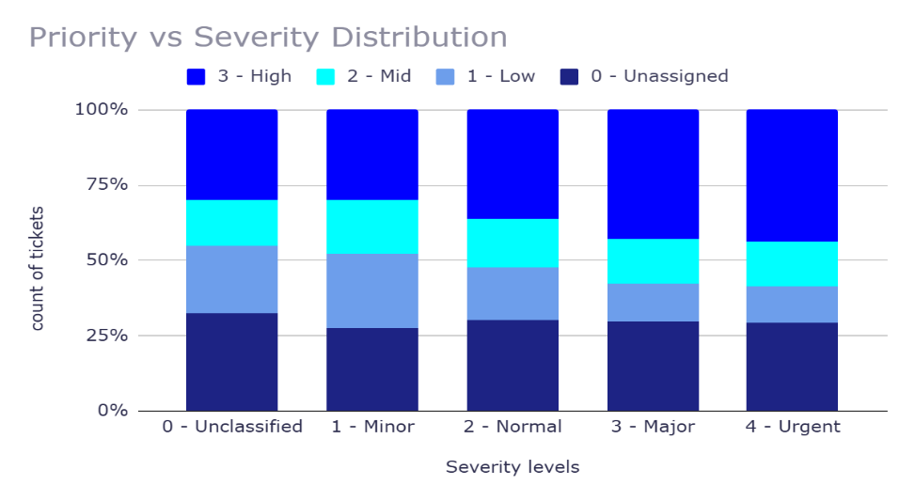

**Reference:**

The analysis evaluates the effectiveness of the current software tools in managing IT tickets by assessing the alignment of priority and severity levels. This comparison is crucial to determine how well the current tools handle ticket categorization, ensuring that high-severity tickets are prioritized correctly.

**Approach:**

1. **Data Organization**:  
   The provided dataset includes ticket counts categorized by severity (0 - Unclassified to 4 - Urgent) and priority (0 - Unassigned to 3 - High). The goal is to assess how the tickets with different severities are distributed across the priority levels.
2. **Analysis of Severity vs. Priority**:  
   The focus is on whether high-severity tickets (such as "Urgent" or "Major") are assigned to higher priority levels (such as "High"), and if low-severity tickets (like "Minor" or "Unclassified") are being appropriately categorized under lower priority levels.
3. **Evaluation of Performance**:  
   By analyzing the severity-to-priority distribution, we aim to determine if the current software tools efficiently categorize and prioritize tickets or if misalignments indicate inefficiencies in ticket management.

**Insights:**

1. **High-Severity Tickets (Urgent and Major)**:
   * **Urgent Tickets**:  
     A total of **409 Urgent tickets** were assigned a **Low priority** while **612 Urgent tickets** were assigned a **High priority**. This misalignment suggests some urgency tickets are not prioritized as needed.
   * **Major Tickets**:  
     There are **1434 Major tickets** assigned to **Low priority** and **2075 Major tickets** assigned to **High priority**, indicating that while most major tickets are appropriately prioritized, some are under-prioritized.
2. **Mid and Low-Severity Tickets (Minor, Normal, and Minor)**:
   * **Minor Tickets**:  
     There were **549 Minor tickets** assigned to **Low priority**, **407 to Mid priority**, and **676 to High priority**. A significant number of **Minor** tickets have been assigned **High priority** even though these typically should be lower priority.
   * **Normal Tickets**:  
     **32080 Normal severity tickets** are predominantly assigned to **High priority**, showing a clear mismatch in severity-to-priority alignment. Typically, Normal severity tickets should be aligned with **Mid** or **Low priority**.
3. **Unassigned Tickets**:  
   The presence of unassigned priority and severity combinations (e.g., **115 Unclassified tickets** with **Unassigned priority**) suggests that there might be gaps in ticket categorization by the system, contributing to inefficiency.

**Recommendations:**

1. **Refine Ticket Categorization**:
   * Ensure that **Urgent** and **Major** tickets are consistently assigned to **High priority**. Tickets with **Minor** or **Unclassified** severity should be more appropriately assigned to **Low** or **Mid priority**.
2. **Improve Software Automation**:  
   Enhance the software tool’s automatic categorization system to minimize errors in assigning severity and priority. Consider adding rules or constraints that prevent high-severity tickets from being assigned to **Low** priority.
3. **Regular Monitoring**:  
   Set up periodic audits to monitor the alignment of severity and priority for tickets and adjust the system based on findings, ensuring ongoing improvement in ticket management.

**5.How has the performance of the IT support team changed over time (e.g., monthly or quarterly)?**

**Analysis: Trend analysis using time series charts.**

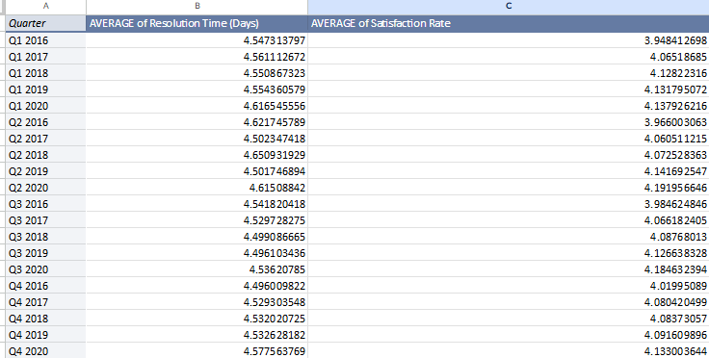

This is the quarterly analysis from the year 2016-2020 being averaged.

How ever the average resolution time is stable around 4.50 days approximately

The satisfaction rate has been gradually increased and maintained above 4.  
  
**Reference:**

This analysis uses **trend analysis** based on quarterly data from 2016 to 2020 to observe the changes in **resolution time** and **satisfaction rate** over time.

**Approach:**

* **Metrics Used**:
  + **Resolution Time (Days)**: Measures the average time taken to resolve IT tickets.
  + **Satisfaction Rate**: Reflects user satisfaction with the IT support provided.
* The data spans from **Q1 2016 to Q4 2020**, with values averaged each quarter.

**Insights:**

* The **average resolution time** has remained **relatively stable** around **4.50 days**, showing **consistency** in the time taken to resolve tickets over the 5-year period.
* The **satisfaction rate** has shown a **gradual increase** over the years, starting at **3.95** in Q1 2016 and increasing to **4.13** in Q4 2020, suggesting a **positive trend** in user satisfaction.

**Recommendations:**

* While the **resolution time** remains stable, continuous efforts to **improve efficiency** could help reduce resolution times further.
* The steady improvement in **satisfaction** should be maintained, and strategies should focus on further enhancing **user experience** to keep the satisfaction rate above **4**.

**6.If we invest more on tech (Hardware, software, etc), do you think it will improve the ticket resolution times and employee satisfaction?**

**Reference:**

* **Category-Wise Metrics** (Satisfaction Rate and Resolution Time) and **Year-Wise Ticket Count** have been analyzed.

**Approach:**

* Analyzed **Satisfaction Rates** and **Resolution Times** across different **Request Categories**.
* Compared **Year-Wise Ticket Counts** to identify trends and demands for IT support.

**Insights:**

1. **Category-Wise Metrics**:
   * **Satisfaction Rates** are **high** across all categories (~**4.1**), indicating strong performance.
   * **Resolution Times** vary:
     + **Login Access** resolves in **0.31 days** (efficient).
     + **Hardware** issues take **7.63 days**, suggesting areas for improvement.
2. **Year-Wise Ticket Trends**:
   * A consistent **increase** in ticket volume from **13,051** (2016) to **29,088** (2020), highlighting the growing demand for IT support.

**Recommendations:**

1. **Focus on Hardware**: Invest in technology to reduce the long **7.63 days** resolution time for **Hardware** issues.
2. **Scale Support for High-Volume Categories**: Given the high ticket count in **Software** and **System** categories, optimize processes to handle growing demand.
3. **Leverage Efficient Practices**: **Login Access** resolutions are fast; applying similar practices could improve resolution times for other categories.

Investing in technology and streamlining support processes will enhance ticket resolution efficiency and employee satisfaction.

**7.What are the key performance metrics for IT agents, and how can they be improved, do we need to fire any agents?**

**Analysis: Define and analyze metrics such as average handling time, satisfaction scores, and number of tickets resolved.**

**A.**

|  |
| --- |
| ***Agent ID*** |
| 3 |
| 6 |
| 7 |
| 9 |
| 11 |
| 16 |
| 18 |
| 19 |
| 22 |
| 25 |
| 26 |
| 28 |
| 30 |
| 33 |
| 37 |
| 40 |
| 41 |

**Reference:**

**The key performance metrics for IT agents include:**

* Resolution Time: Measures the average time taken to resolve a ticket.
* Satisfaction Rate: Measures user satisfaction with the resolution of the issue.
* Number of Tickets Resolved:Indicates the volume of work handled by each agent.

**Approach:**

* Analysis: The analysis identifies agents who have long resolution times and low satisfaction rates, which can indicate areas for improvement. The key metrics for assessment are:
  + Average Resolution Time (Days)
  + Average Satisfaction Rate
  + Number of Tickets Resolved
* "Needs Improvement" Agents: Agents with both high resolution times and low satisfaction scores need additional training or support.

**Insights:**

* Agents with long resolution times and low satisfaction rates (e.g., Agent ID 3, 6, 7, 9, 19) are underperforming.
* These agents consistently show resolution times above 4.5 days and satisfaction rates below 4.
* Improvement areas: Focus on improving handling times and customer satisfaction through better tools, training, and performance monitoring.

**Recommendations:**

* Training: Provide targeted training for agents with high resolution times and low satisfaction scores to improve their efficiency and customer handling.
* Monitor Performance: Track progress with performance metrics and set clear improvement goals.
* No Immediate Firing: There is no immediate need to fire agents based solely on their metrics. Instead, a focused improvement plan should be implemented, with a follow-up evaluation after a specified period.
* If after a reasonable period there is no improvement, further performance management steps may be considered.

**8.**How do employee demographics (e.g., department, seniority) impact satisfaction and ticket outcomes?

Analysis: Segment analysis using filters and pivot tables.

**A.**

|  |  |  |
| --- | --- | --- |
| *Senority* | AVERAGE of Satisfaction Rate | AVERAGE of Resolution Time (Days) |
| Junior | 4.212856316 | 4.49391931 |
| Mid | 4.124884808 | 4.694699478 |
| Senior | 4.054046868 | 4.49187208 |

where senority is allotted when the birth year is less than 30 set as Junior,greater than less than 40 set as mid , and else as senior

**1. Reference:**

The analysis categorizes employees based on their **seniority**:

* **Junior**: Birth year less than 30
* **Mid**: Birth year between 30 and 40
* **Senior**: Birth year greater than 40

The impact of seniority on **Satisfaction Rate** and **Resolution Time** is evaluated by averaging these metrics for each category.

**2. Approach:**

* **Data Segmentation**: Employee data was categorized into three seniority levels based on birth year.
* **Metric Analysis**: The **Satisfaction Rate** and **Resolution Time (Days)** were averaged for each group to assess performance.

**3. Insights:**

* **Juniors**: The highest **Satisfaction Rate** of 4.21, but slightly higher **Resolution Time**.
* **Mids**: The longest **Resolution Time** (4.69 days) and lower **Satisfaction Rate** (4.12), which suggests potential inefficiencies in this group.
* **Seniors**: The lowest **Satisfaction Rate** (4.05) but **Resolution Time** similar to Juniors (4.49 days), indicating possible dissatisfaction despite efficient resolution.

**4. Recommendations:**

* **Juniors**: Focus on maintaining high satisfaction while streamlining processes to reduce resolution time.
* **Mids**: Investigate the causes of **higher resolution times**—consider additional training, better tools, or workflow optimization to improve efficiency and satisfaction.
* **Seniors**: Address the **lower satisfaction rates** through targeted interventions, such as additional support, engagement initiatives, or role-specific improvements.

**9.**Identify the trends for IT support operations based on ticket volumes and satisfaction, and mention the peak and stable times?Analysis: Use pivot tables and charts to identify peak and off-peak hours.

**A.Peak Ticket Volume (105):**

* **Interpretation:s**
  + The team is managing high ticket volumes without directly affecting satisfaction rates.
  + Indicates good resource allocation or efficient handling during peak times.
* **Action:**
  + Maintain current strategies for peak periods.
  + Monitor closely for potential delays or drops in satisfaction if volumes increase further.

**Low Satisfaction Period (3.07):**

* **Interpretation:**
  + Low satisfaction is not tied to peak ticket volumes but may result from other factors:
    - Agent performance issues.
    - Complex ticket types.
    - Delays in resolution during stable periods.
* **Action:**
  + Investigate ticket categories, agent performance, or resolution times during this period.
  + Address specific bottlenecks (e.g., better training or software improvements).

**10.What metrics should be included in the final dashboard to provide a comprehensive view of call center performance and guide investment decisions?**

**A.**

**Agent Performance Metrics:**

1. **Tickets Handled Per Agent:**
   * Use a pivot table with Agent ID in rows, count of Ticket IDs as values.
   * Optionally add filters for date ranges (daily, weekly, monthly).
2. **Agents with High/Low Satisfaction Rates:**
   * Sort agents based on Satisfaction Rate.
   * Highlight top and bottom performers using conditional formatting.
3. **Agent Seniority vs. Resolution Efficiency:**
   * Create a scatterplot with Seniority on one axis and Resolution Time on the other.
   * Use Agent IDs as labels.

**Satisfaction Overview Metrics:**

1. **Average Satisfaction Rate by Agent and Seniority:**
   * Use a pivot table with Agent ID and Seniority in rows, average Satisfaction Rate as values.
   * Apply conditional formatting for easy visualization.

**Ticket Volume Metrics:**

1. **Total Tickets Resolved:**
   * Use a pivot table with:
     + Rows: Fecha (grouped by day, week, month).
     + Values: Count of Ticket IDs.
2. **Peak and Off-Peak Ticket Volumes:**
   * Identify peaks by sorting ticket counts by day or time.
   * Use a line or bar chart for visualization.